docker push anilbidari/ubuntu:1.0

docker login

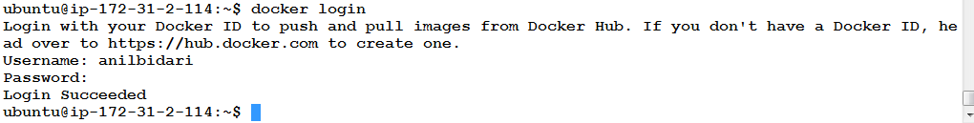

docker push anilbidari/ubuntu:1.0

docker rmi -f <imageid>

docker images

docker run -it anilbidari/ubuntu:1.0 /bin/bash